# Irrigation and Motors

1. Alter table Machine, add new columns: Hydrometer, Hourmeter

|  |  |
| --- | --- |
| Machine | |
| ….. |  |
| Hourmeter | double |
| Hydrometer | double |
| …. |  |

1. (?)Expand Transaction Types Table to include “Fuel Deposit” and “Gauge Adjustment- Up”, “Gauge Adjustment _Down”. “Fuel deposit” is to be used to indicate Fuel Purchase and “Withdrawal “to indicate usage. Since there is no exact way to keep track of tank level we should adjust the gauge measurements. (?)
2. **Fuel Purchases**

**Data Structure**

|  |  |  |  |
| --- | --- | --- | --- |
| Fuel Purchases | | | |
| PK | Invoice Id |  |  |
|  | Suppler Id | FK |  |
|  | Fuel Type Id | FK |  |
|  | Iva rate Id | FK |  |
|  | Invoice Number |  | text |
|  | Quantity |  | real |
|  | Unit Cost |  | real |
|  | Subtotal |  | real |
|  | Taxes |  | real |
|  | Total |  | real |
|  | Date & Time |  | Date |
|  | Note |  | text |
|  | Invoice Document Link |  | text |

**UI, BUSINESS LOGIC and RULES**

1. **To view list of existing invoices**

User navigates to Diesel 🡪 Invoices tab. Under “Invoice” Tab user can pick from “Invoice List “and “Register New Invoice”.

Under “Invoice List” tab user should be able to see list of previously entered Purchase Invoices in descending order by the date (from current to past (earliest)).

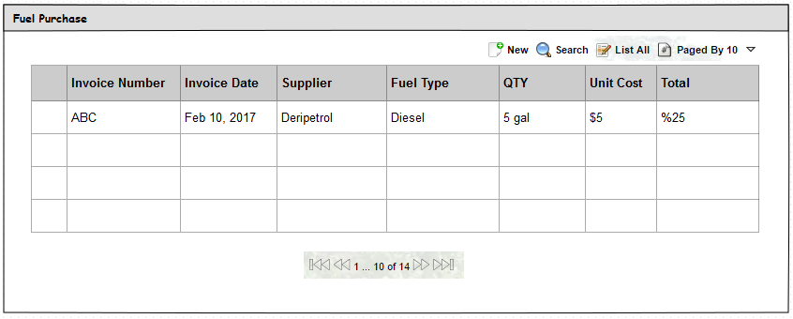

1. **Search**

To locate Invoice record user should be able to click on the “Search” icon and search by Supplier, Invoice Date Range and Invoice Number.

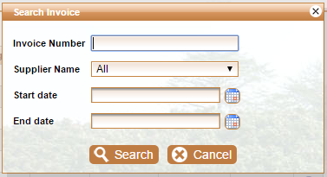

1. **New invoice registration**
2. User clicks on “NEW”. System opens new screen with new invoice entry form.(Optionally User can access “New Invoice” screen by selecting “Register New Invoice” from Invoice sub- menu.
3. User enters information. Required fields marked with asterisk *.
4. User clicks on “Attach Document” to upload related file.
5. User clicks on SAVE.
6. Before saving a record, system validates Invoice number and Supplier combination being unique.
7. If same invoice number has been found for selected supplier system should emit error:

*Duplicate Invoice: Same invoice number exists for selected Supplier.*

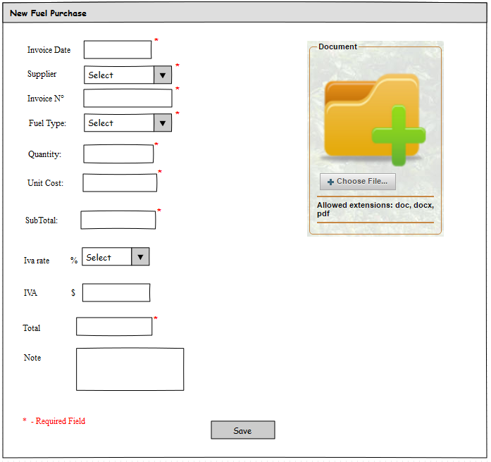

1. The system save in the table “Fuel Usage Log”, the entry of fuel in the fields: Deposited, Final Level and Transaction Type (Fuel Deposit).

|  |  |  |
| --- | --- | --- |
| Fuel Usage Log | | |
| Usage Log Id | PK |  |
| Engine Log Id | FK |  |
| Fuel Purchase Id | FK | Comes from fuel purchase |
| Consumption | double |  |
| Final Level | double | Calculated Field |
| Deposited | double |  |
| Transaction Type ID | FK | Comes from Transaction Type table |
| Note | text |  |

1. **Adjustments**

User navigates to Diesel 🡪 Fuel Usage tab. Under “Diesel” Tab user can pick from “Fuel Usage Log”.

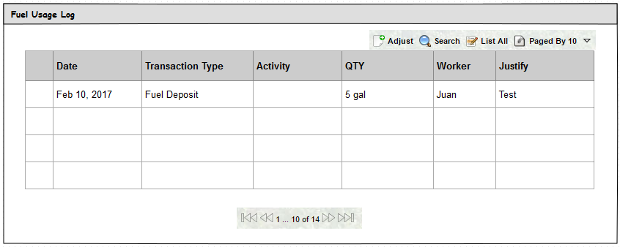

**Adjust**

Since there is no exact way to keep track of tank level we should adjust the gauge measurements.

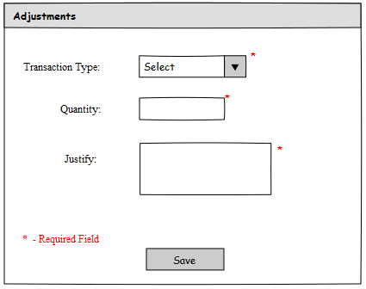

1. User clicks on “Adjust”. System opens new screen with new Adjustments form.
2. User enters information. Required fields marked with asterisk *.
3. User clicks on SAVE.
4. Before saving a record, system validates that Final Level is greater than zero when Transaction Type is "Gauge Adjustment _Down".
5. If final Level is not greater than zero when Transaction Type is "Gauge Adjustment _Down system should emit error:

*Final Level should be greater than zero, please verify.*

1. The system calculate the Final Level field before the save the information in the table Fuel Usage Log.
2. The Final Level field is up when Transaction Type is “Gauge Adjustment Up”.
3. The Final Level field is down when Transaction Type is “Gauge Adjustment Down”.
4. The system shows the message of information.
5. **Engine Log and Irrigation Details**

**Data Structure**

|  |  |  |
| --- | --- | --- |
| Engine Log Table | | |
| Engine Log Id | PK |  |
| Date |  |  |
| Delivered Id | FK | User to select HR Id. |
| Received Id | FK | User to select HR Id. We may want to create team of Operators and let user to select person in the group (optional) |
| Engine Id |  |  |
| Hour On |  |  |
| Hour Off |  |  |
| Hour meter On |  |  |
| Hour meter OFF |  |  |
| Duration |  | In hours |
| Consumption |  | Double |
| Irrigation | Boolean |  |
| Activity ID |  | If Irrigation is FALSE user should be able to select activity that took place on the same DATE and has record in Activity- Machine table with that Date. If Irrigation flag is TRUE than this field to remain NULL |
|  |  |  |

|  |  |
| --- | --- |
| Irrigation Details | |
| ID | PK |
| Engine Log ID | FK |
| Zone ID | FK |
| Machine Id | FK |
| Hidrometer ON | Time (HH:MM) |
| Hidrometer OFF | Time(HH : MM) |
| Water Usage | Double |
| Water Cost | double |
| Duration | double |
| Depreciation Cost | double |
| Maintenance Cost | double |
| Observations | text |

**UI, BUSINESS LOGIC and RULES**

1. **To view list of Engine Log**

User navigates to Diesel 🡪 Invoices tab. Under “Engine Log” Tab user can pick from “Engine Log List “and “Register New Engine Log”.

Under “Engine Log List” tab user should be able to see list of previously entered Engine Log in descending order by the date (from current to past (earliest)).

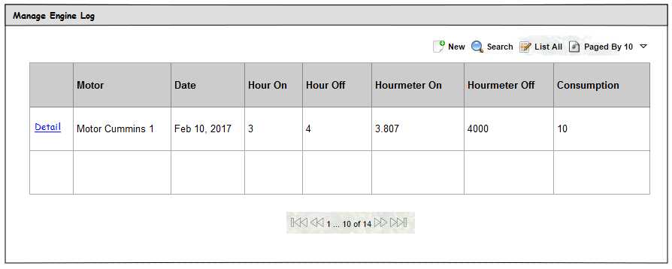

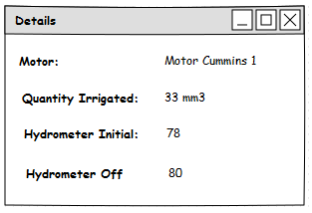

1. **Search**

To locate Engine Log record user should be able to click on the “Search” icon and search by Dates and hours.

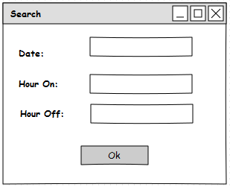

1. **New Engine Log Registration**

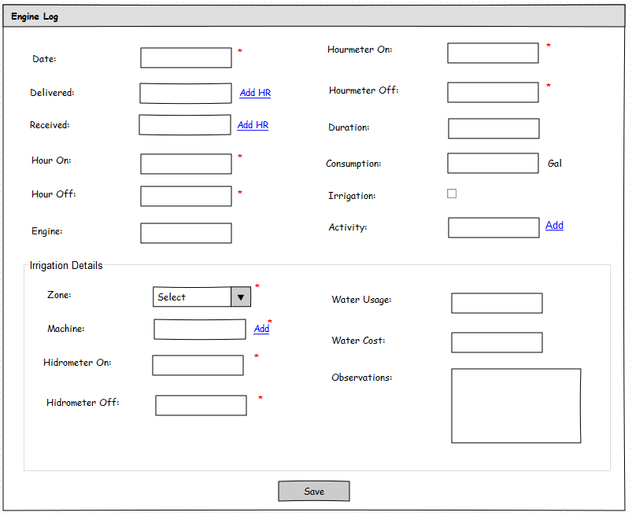

1. User clicks on “NEW”. System opens new screen with new engine log entry form.
2. User enters information. Required fields marked with asterisk *.
3. If Irrigation is FALSE user should be able to select activity-machine (engine) that took place on the same DATE and has record in Activity- Machine table with that Date and Machine has “Fuel “ flag = TRUE. If Irrigation flag is TRUE than this field to remain NULL.
4. If Irrigation is TRUE user should enter the information about Irrigation Details.
5. User do click in Save**.**
6. The system saves the information in the tables: Engine Log, Irrigation Details and Fuel Usage Log.
7. The system calculate the Final Level field before the save the information in the table Fuel Usage Log.
8. The system update the hydrometer field and hourmeter filed in machine table.
9. The system shows the message of information.
10. **Value tables**

**Data Structure**

|  |  |  |
| --- | --- | --- |
| Consumable Resources | | |
| Resource Type | text |  |
| Unit Id | FK |  |
| Unit Cost | double |  |

|  |  |  |
| --- | --- | --- |
| Zone | | |
| Name | text |  |
| Zone Id | PK |  |